MLOPS Assignment 1

Group Number 119

Group Members-
G.Anil Kumar - 2023aa05757 - 100%
Abhishek Lalwani - 2024AA05248 - 100%
Manaswee Adwant - 2024aa05859 - 100%
Gaurav Pathak - 2024aa05031 - 100%
Bala Jagadish - 2024aa05452 - 100%

MLOps Project Report: Heart Disease Prediction

1. Introduction
This report presents an end-to-end MLOps pipeline developed for predicting the presence of heart disease using clinical data. The objective of the project is not limited to building a machine learning model, but to demonstrate how such a model can be trained, tested, deployed, and monitored in a reproducible and production-ready manner.

2. Dataset and Problem Statement
The dataset used in this project is the UCI Heart Disease dataset, which contains patient-level clinical attributes such as age, sex, chest pain type, blood pressure, cholesterol levels, ECG results, and exercise-induced angina. The original dataset contains multiple target classes representing different stages of heart disease. For this project, the problem was simplified into a binary classification task where 0 represents no heart disease and 1 represents the presence of heart disease.

3. Exploratory Data Analysis (EDA)
Exploratory Data Analysis was performed to understand the distribution of features and their relationship with the target variable. Key observations included variations in heart disease occurrence across age groups, gender, and chest pain types. Correlation analysis helped identify clinically relevant features that influence the prediction outcome.

4. Feature Engineering
Numerical features were standardized using a preprocessing pipeline. All transformations were encapsulated inside a single pipeline to prevent train-serve skew and ensure consistent preprocessing during inference.

5. Model Selection and Training
Logistic Regression was selected as the primary model for this project. The choice was motivated by its interpretability, simplicity, and suitability for binary classification problems in the healthcare domain. The model was trained on preprocessed data and evaluated using standard metrics such as accuracy, precision, and recall.
MLflow was used to track experiments, including model parameters, evaluation metrics, and trained artifacts. This enabled reproducibility and easy comparison between different training runs.

6. CI/CD Pipeline and Automated Testing
A CI/CD pipeline was implemented using GitHub Actions. The pipeline is triggered on every push to the ci-cd branch. It installs dependencies, runs unit tests using Pytest, and validates the codebase. This ensures that any change to the code is automatically tested before being considered for deployment.
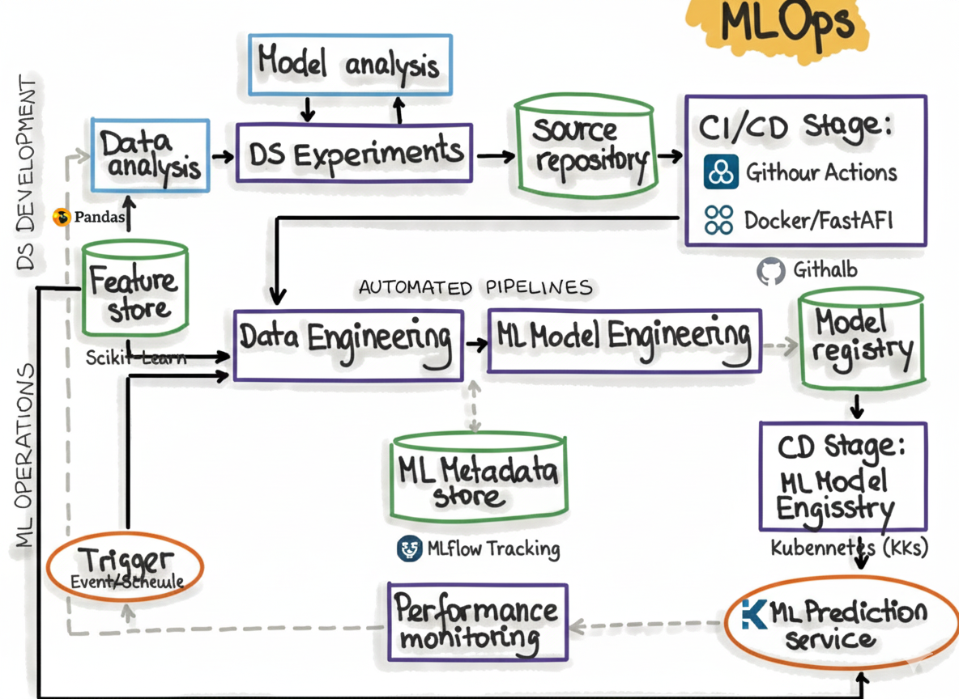

7. Model Serving and Containerization
The trained Logistic Regression model was served using a FastAPI-based REST API. The API exposes a /predict endpoint that accepts JSON input and returns both the prediction and a confidence score. The application was containerized using Docker, ensuring consistency across environments.

8. Deployment and Monitoring
The Dockerized application was deployed locally using Docker Desktop and Kubernetes. Kubernetes deployment and service manifests were created to manage the application lifecycle and expose the API using a NodePort. Basic monitoring was implemented using Prometheus-compatible metrics such as request count and latency, exposed via a /metrics endpoint.

9. Conclusion
This project demonstrates a practical MLOps workflow covering data analysis, model training, CI/CD automation, containerization, deployment, and monitoring. The implementation reflects real-world practices and highlights the importance of operationalizing machine learning systems beyond model development.

Screenshots:
